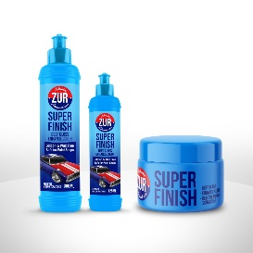

**Product Information**

* **Available packaging**

|  |  |
| --- | --- |
| Paste | liquid |
| 75 ml | **125 Ml** |
| 150 ml | **250 Ml** |
| 250 Ml | **1000 Ml** |
|  |  |

**Product description**

* **Polishing compounds delivers a mirror shine with durable protection, the advanced polish formulated using diminishing abrasive technology.**
* **rapid removal of minor surface defects and swirl marks from all modern paint systems. Superb on darker colours.**
* **High gloss and low dust technology.**
* **High lubrication system with longer polishing time.**
* **Low consumption and time saving formula.**
* **No aggressive smell & Easy to be wiped off.**

**ml ml**

**ml ml**

**Cutting range**

**ml ml**

**ml ml**

**ml ml**

**ml ml**

**Gloss range**

**Key benefits**

* **Permanent finish contains no fillers so scratch marks won’t re-appear.**
* **High gloss system Excellent gloss .**
* **Silicone free 100% paintshop safe**
* **Swirl remover Swirl and holograms eliminated permenantly**
* **Can be used by machine with foam or lamb wool applicator as well as by hand**



**Machine Application**

**1**

**3**

**4**

**5**

ATTACH

1500 - 2000

**Soak the compounding foam in water.**

**Attach the pad to the polishing machine spin off the excess water.**

**Spread at 1000 rpm and Polish at 1500 – 2000 rpm with light pressure**

**Wipe clean with Finishing Cloth.**

**Hand Application**

**1**

**2**

**3**

**4**

**Soak the hand compounding foam or the microfiber cloth in water.**

**Rub the product on the surface in back and forth motion**

**Apply water if necessary. Wipe clean with microfiber cloth.**

**How To Use**

**Shake or mix the compound well , then apply to the pad or surface.**

**Shake or mix the compound well , then apply to microfiber cloth or surface.**